Due to error while uploading the task to platform I deleted the data file which contains input and output data, and uploaded the file separately to google drive. File can be accessed with link https://drive.google.com/drive/folders/1l_WqLa2TAvqZhl9cFODuk8YpLy1BtdUM?usp=sharing

Restaurant Weather ETL Pipeline Report

1. Introduction
The purpose of this project is to develop a data processing pipeline capable of integrating restaurant and weather datasets. The solution uses Apache Spark to perform scalable ETL operations and enrich restaurant information with weather-related data.
The project demonstrates practical implementation of data engineering concepts including data ingestion, transformation, API integration, geospatial processing, and automated testing.

2. Project Objectives
The project aims to:
- Read restaurant data from local storage.
- Read weather data from local storage.
- Detect missing latitude and longitude values.
- Retrieve missing coordinates through the OpenCage Geocoding API.
- Generate four-character geohashes.
- Join restaurant and weather datasets.
- Store processed data locally.
- Automate execution through scripts.
- Validate functionality using tests.

3. Technology Stack

Programming Language
Python 3.11

Frameworks and Libraries
- Apache Spark (PySpark)
- Geohash2
- Requests
- Python Dotenv
- PyTest

External Service
OpenCage Geocoding API

Version Control
Git and GitHub

Operating System
Windows 11

4. Hardware Specification
Machine used for development:
- CPU: Intel Processor
- RAM: (Insert your RAM amount)
- Storage: SSD
- Operating System: Windows 11

5. Project Structure
The project follows a modular structure:
spark-restaurant-weather-etl/
├── data/
│ ├── input/
│ ├── output/
├── src/
├── tests/
├── run.bat
├── requirements.txt
├── .gitignore
└── README.md
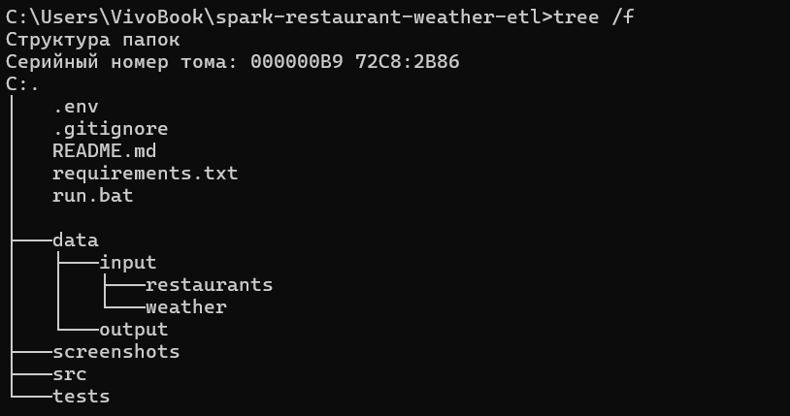

6. Data Sources

Restaurant Dataset
Contains:
- Restaurant ID
- Franchise ID
- Franchise Name
- Country
- City
- Latitude
- Longitude

Weather Dataset
Contains:
- Latitude
- Longitude
- Average Temperature (F)
- Average Temperature (C)
- Weather Date

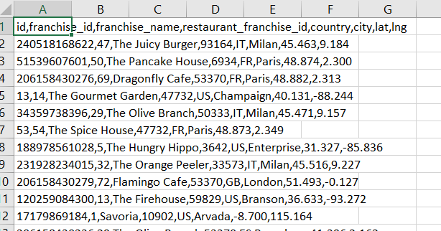

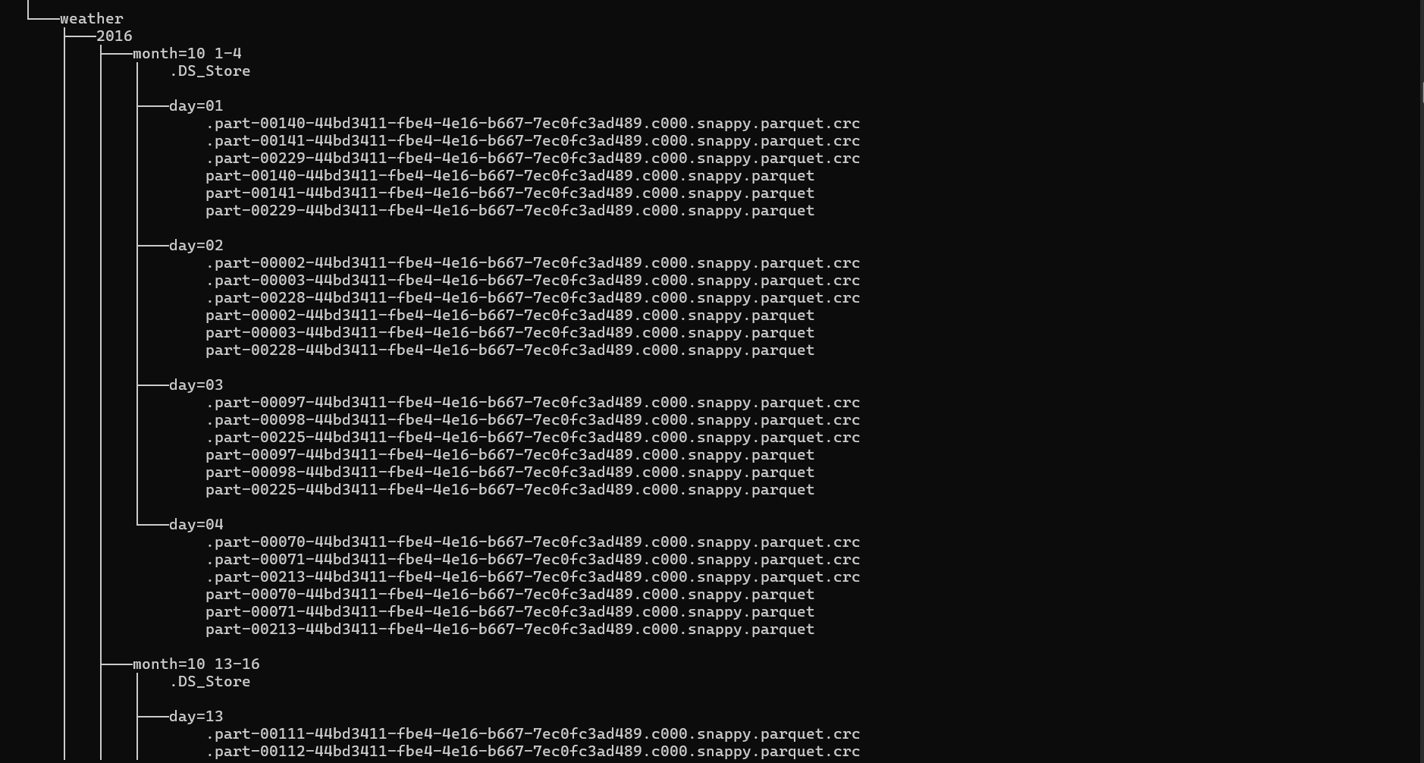

7. ETL Pipeline Design

Step 1 – Data Extraction
Restaurant data is loaded from CSV files.
Weather data is loaded from partitioned Parquet files.

Step 2 – Data Validation
Latitude and longitude fields are checked for missing values.

Step 3 – Coordinate Enrichment
For records with missing coordinates, OpenCage API is used to retrieve latitude and longitude values.

Step 4 – Geohash Generation
A four-character geohash is generated using latitude and longitude coordinates.

Step 5 – Dataset Join
Restaurant and weather datasets are joined using geospatial information.

Step 6 – Data Storage
Processed records are written to Parquet files.

8. Workflow Diagram

11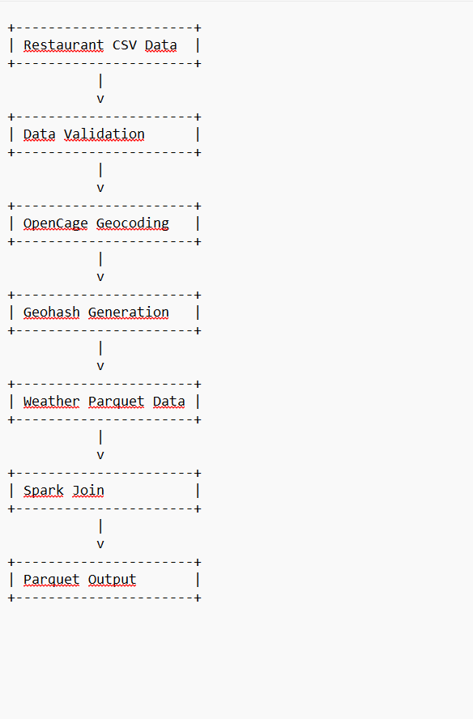

9. Running the Pipeline
Execute:
python src/restaurant_weather_etl.py
or
run.bat

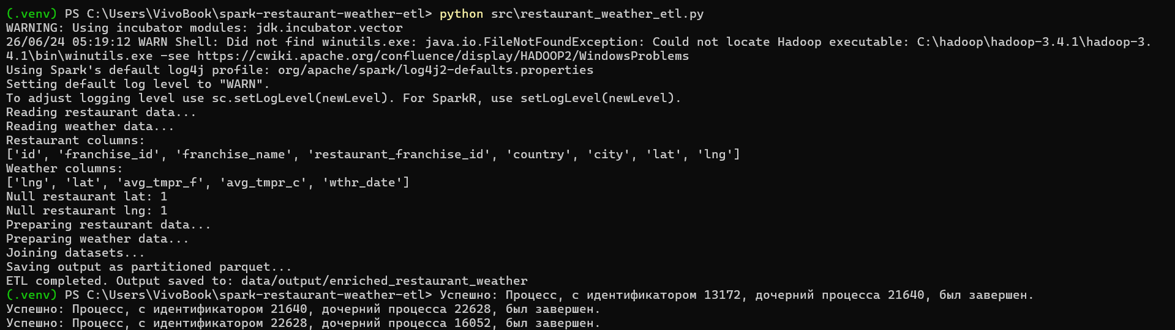

10. Testing
Unit testing is performed using PyTest.
Command:
pytest
The tests verify:
- Data loading
- Coordinate validation
- Geohash generation
- Dataset transformations

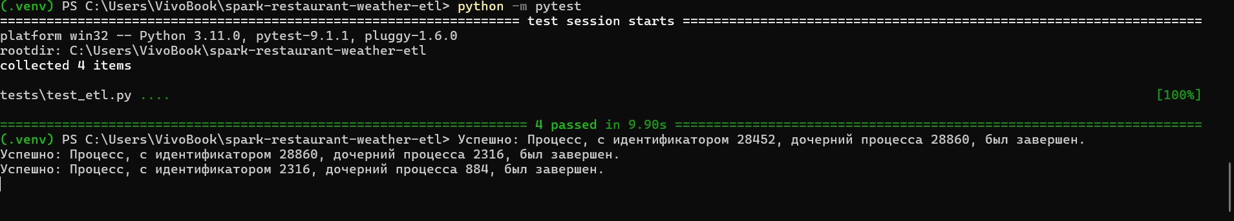

11. Results
The pipeline successfully:
- Loaded restaurant data.
- Loaded weather data.
- Identified missing coordinates.
- Enriched missing location information.
- Generated geohashes.
- Joined weather and restaurant datasets.
- Produced enriched output files.

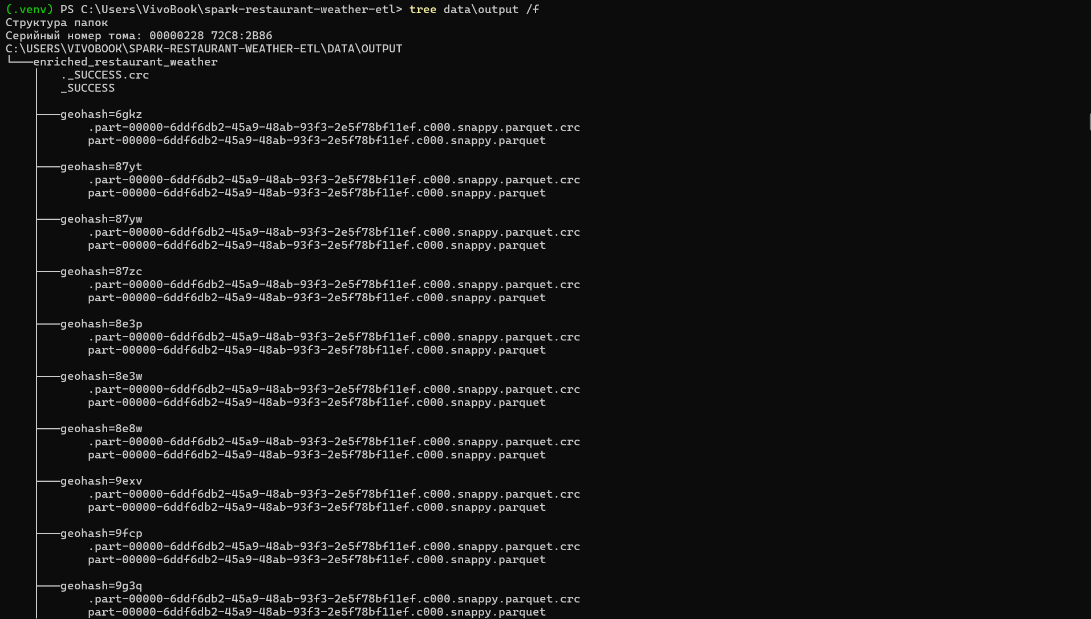

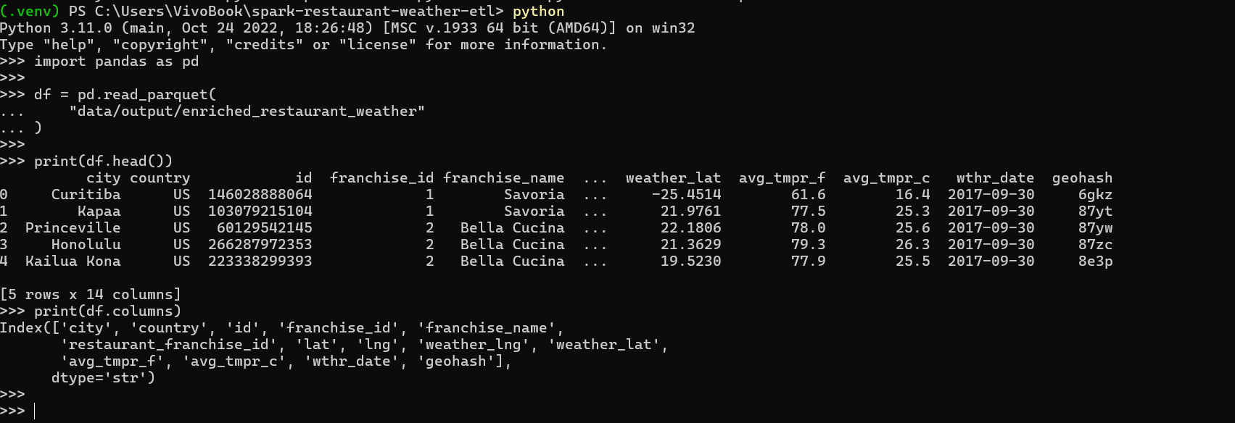

12. Challenges Encountered
Several technical challenges were encountered:
- Python and Spark compatibility issues.
- Weather dataset partition handling.
- Windows Spark configuration.
- Geohash implementation compatibility.
- Duplicate column handling during joins.
Solutions were implemented to resolve each issue and stabilize the pipeline.

13. Conclusion
This project successfully demonstrates a complete ETL workflow using Apache Spark. The solution integrates multiple datasets, enriches missing information through an external API, performs geospatial transformations, and stores the final dataset in an optimized format.
The project satisfies all specified functional requirements and provides a reusable framework for future data engineering tasks.

